FRESHMAN&SOPHOMORE

PLANNING

**CONGRATULATIONS!**

**You made it to HIGH SCHOOL!**

Here are some helpful pages of information to help guide you along the way. If you have any questions, see your counselors for help!

Professional & Technical High School

501 Simpson Road

Kissimmee, FL 34744

Phone: 407-518-5407

Fax: 407-344-2467

**Table of Contents**

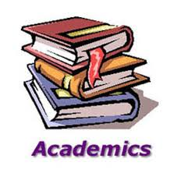 **High School/Academics Terms to Know**

**Graduation Requirements**

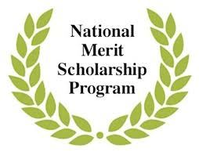 **Scholar/Merit Designation**

**Freshman Checklist**

**Sophomore Checklist**

 **College & Career Planning**

** Osceola Virtual School**

**Community Service Guidelines**

**Osceola Technical College Programs**

**Dual Enrollment**

**Florida Bright Futures Scholarships**

**High School / Academics**Terms to Know

**Advanced Placement (AP):**AP courses are college-level classes taught in the high school following guidelines and covering material that will instruct students in AP subject areas and should prepare them to take Advanced Placement tests offered by The College Board.

**Community Service:**Volunteer (un-paid) work intended to help people in an area/community. These hours should be reported to your counselor to be recorded and added into your student record.

**Dual Enrollment:** An acceleration program that allows high school students to enroll to take college courses while still in high school. Students will earn credits towards a college degree and also earn high school credit.

**Career Dual Enrollment:** is a specific form of dual enrollment in which students enroll in postsecondary courses that lead to an industry certification. Career dual enrollment is available to students in public schools, home education, and private high schools.

**Extra-curricular Activities:**You should define your extracurricular activities in broad terms—many students make the mistake of thinking of them solely as school-sponsored groups such as yearbook, band or football. Not so. Most community and family activities are also "extracurricular."

**GPA (Grade Point Average):**Quantitative measure of a student's grades. The GPA is figured by averaging the numerical value of a student's grades. It is cumulative, starting freshman year with grades counting every year.

**GPA- Unweighted:** The calculation of the average of all a student’s high school courses on 4.0 scales is an unweighted GPA. It does not take into account the rigor of the coursework.

**GPA- Weighted:** This calculation of the average of all the student’s high school courses adds weight to classes that entail more rigor. The GPA is calculated with a 5.0 scale. (Honors classes at the high school level add 0.5 to the grade calculation for a course, while AP and Dual Enrollment courses receive and added 1.0 increase for the course.

**Recommendations:**Statements or letters of endorsement written on a student’s behalf. These are often used for applications for college, scholarships, volunteering or employment.

**Transcript:**This is the official document containing the record of a student’s academic performance and testing history throughout their *entire* high school career.

Graduation Requirements

* 4 Credits of English
* 4 Credits of Math (including Algebra I, Geometry, and above
* Algebra I EOC Geometry EOC *(must take)*
* 3 Credits of Science (a 4th science recommended for College)
* Biology I EOC *(must take)*
* 1 Credit of World History
* 1 Credit of American History
* American History EOC *(30% of final grade)*
* ½ Credit of U.S. Government
* ½ Credit of Economics
* 1 Credit of Phys. Ed. with the integration of Health
* 1 Credit of Fine/Practical/Performing Art
* 8 Elective Credits
* Including 1 online course through Osceola Virtual School
  + **Additional Requirements**
* 10th Grade FSA (Reading Level 3)
* Algebra I EOC Level 3
* 2.0 Unweighted GPA

For requirements specific to your Graduating Class, visit Florida Department of Education

<http://www.fldoe.org/academics/graduation-requirements/>

**4-year College entrance requires at least 2 consecutive credits of a foreign language

Scholar & Merit Diploma Designations

In addition to meeting the 24-credit standard high school diploma requirements, a student must meet the following requirements:

Scholar Diploma Designation

* Earn 1 credit in Algebra II
* Pass the Geometry EOC
* Earn 1 credit in statistics or an equally rigorous mathematics course
* Pass the Biology I EOC
* Earn 1 credit in chemistry or physics
* Earn 1 credit in a course equally rigorous to chemistry or physics
* Pass the U.S. History EOC
* Earn 2 credits in the same world language
* Earn at least 1 credit in AP, IB, AICE or a dual enrollment course.
* A student is exempt from the Biology I or U.S. History assessment if the student is enrolled in an AP, IB or AICE Biology I or U.S. History course and the student
* Takes the respective AP, IB or AICE assessment; and
* Earns the minimum score to earn college credit.

Merit Diploma Designation

* Attain one or more industry certifications.

FRESHMAN CHECKLIST

* **Maintain your GPA** **–** You’ll find that it’s easy to tank a GPA by earning a bad grade, but it is quite difficult to bring it back up again.
* **Freshman Reviews** **–** every ninth-grade student and parent are required to meet with his/her counselor to make sure they are on track to graduate.
* **PSAT –** take**,** practice, reviewand focus on weak areas to prep for future testing
* **Building your Resume** **–** start being active, participate and get involved in school. Clubs, Extracurricular Activities, Sports, Volunteer Work, Jobs, Academic Competitions, awards, etc.
* **Get to know teachers and counselors –** so they can get to know you. At some point you will need recommendations for summer programs, scholarships, and/or college applications.
* **Start a list of post-secondary options –** (military; tech; college/university) & start researching.
* **Find fun and interesting ways to volunteer**  *(try to find opportunities in your field of interest*). The sooner you start, the more you’ll earn throughout your high schools’ years. You don’t want to be behind Senior Year when you’re wanting a good number of hours for college applications and scholarships!
* **TAKE ALL TESTS & EXAMS SERIOUSLY** – THESE WILL IMPACT YOUR FUTURE!!!!!
* **Complete Xello task** – SMART Goals, Build Resume, Career cluster. Starting to explore **Xello** will help you get ready for you career and college goals.

SOPHOMORE CHECKLIST

* **Begin Talking About Life After High School** – Discuss possible career choices, college preferences, and other ambitions.
* **Consider Preliminary Testing** – Although it’s still early to get a very good read on standardized testing potential, having some rough idea of a starting point will ultimately make standardized test prep a little easier later. Take the **PSAT, PERT.**
* **Explore Careers** **–** Startto gain actual experience in certain career fields. Gain experience through volunteer opportunities or unpaid internships. Talk to your counselor about interests, ambitions and consider different angles for applying them towards a future career.
* **Take Personality or Career Tests** **–** Through **Xello** you will have the opportunity to take personality and career tests which can be a fun way for you to start to consider options and to frame your strengths and interests in a productive way.
* **Learn About the College Application Process –** Set aside some time to do some online research, pick up a few relevant, updated books or magazines, or chat with your counselor or with someone who’s gone through the process recently.
* **Get More Involved in Extracurriculars –** While freshman year was a time to explore new options and branch out, sophomore year is time to focus in. Identify the activities for which you truly have a passion, and invest more time in these while letting other, less productive activities go.



College and Career Planning

* **Understand** college possibilities
* **Explore** high school specific college admissions stats
* **Match** to best-fit colleges
* **Identify** ideal college majors
* **Connect** interests to career fields
* **Identify** best-fit careers
* **Plan** for life after high school
* **College Preparation –** By matching students to colleges based on students’ interests and goals, and comparing admissions rates at students’ top college choices, the **Xello** college planning tools allow students and families to make informed decisions. **Xello** helps students find their best-fit higher education institution.
* **Self-Assessments** **–** helping students understand their personality type, learning styles, and unique intelligences. Together, the assessments provide a comprehensive profile of students' strengths and personal attributes that gives students the tools they need to take charge of their own learning.
* **Career Assessment** **–** Career Key's scientific matching system enables students to identify careers and college majors that match their interests, traits, skills and abilities

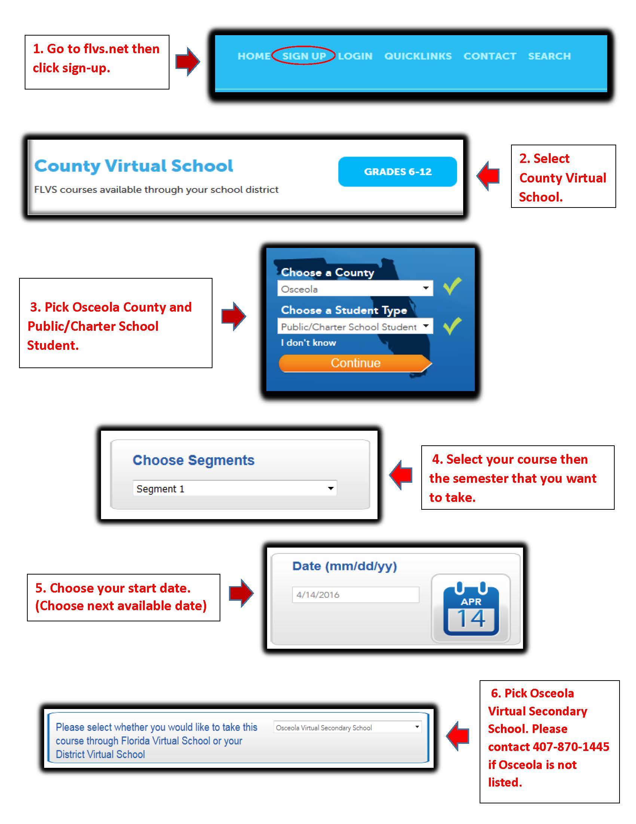OSCEOLA VIRTUAL SCHOOL



OSCEOLA TECHNICAL COLLEGE

**CAREER CERTIFICATES**

**Architecture & Construction**

* [**Electricity**](https://otec.osceolaschools.net/our_programs/career_certificates/architecture___construction/Electricity)
* [**Heating, Ventilation, Air-Conditioning/Refrigeration**](https://otec.osceolaschools.net/our_programs/career_certificates/architecture___construction/heating_ventilation_air-conditioning_refrigeration)
* [**Plumbing**](https://otec.osceolaschools.net/our_programs/career_certificates/architecture___construction/plumbing_)

**Arts, A/V Technology & Communication**

* [**Digital Design**](https://otec.osceolaschools.net/our_programs/career_certificates/arts__a__v_technology___communication/digital_design)

**Business Management & Administration**

* [**Legal Administrative Specialist**](https://otec.osceolaschools.net/our_programs/career_certificates/business_management___administration/legal_administrative_specialist)
* [**Medical Administrative Specialist**](https://otec.osceolaschools.net/our_programs/career_certificates/business_management___administration/medical_administrative_specialist)

**Health Science**

* [**Dental Assisting**](https://otec.osceolaschools.net/our_programs/career_certificates/health_science/dental_assisting)
* [**Medical Assisting**](https://otec.osceolaschools.net/our_programs/career_certificates/health_science/medical_assisting)
* [**Medical Coder/Biller**](https://otec.osceolaschools.net/our_programs/career_certificates/health_science/medical_coder__biller)
* [**Medical Laboratory Assisting**](https://otec.osceolaschools.net/our_programs/career_certificates/health_science/medical_laboratory_assisting)
* [**Pharmacy Technician**](https://otec.osceolaschools.net/our_programs/career_certificates/health_science/pharmacy_technician)
* [**Phlebotomy**](https://otec.osceolaschools.net/our_programs/career_certificates/health_science/phlebotomy_course)

**Hospitality & Tourism**

* [**Professional Culinary Arts & Hospitality**](https://otec.osceolaschools.net/our_programs/career_certificates/hospitality___tourism/culinary_arts)

**Information Technology**

* [**Applied Cybersecurity**](https://otec.osceolaschools.net/cms/One.aspx?portalId=614400&pageId=44663099)
* [**Computer Systems & Information Technology**](https://otec.osceolaschools.net/cms/One.aspx?portalId=614400&pageId=27377764)
* [**Network Support Services**](https://otec.osceolaschools.net/cms/One.aspx?portalId=614400&pageId=2794754)

**Manufacturing**

* [**CNC Production Specialist**](https://otec.osceolaschools.net/cms/One.aspx?portalId=614400&pageId=27352301)

**Transportation, Distribution & Logistics**

* [**Automotive Maintenance and Light Repair Technician**](https://otec.osceolaschools.net/cms/One.aspx?portalId=614400&pageId=2835735)

All PATHS students are required to be in a career certification program.

**Carl F. Martin**

**Ext. 15302**

**PROFESSIONAL SCHOOL COUNSELOR**

**Carl.Martin@OsceolaSchools.net**

[**http://bit.ly/Martinbookings**](http://bit.ly/2OblOZG)

**Kelly Aycock**

**Ext. 15301**

**PROFESSIONAL SCHOOL COUNSELOR**

**Kelly.Aycock@OsceolaSchools.net**

[**http://bit.ly/**](http://bit.ly/Ospinabookings)**MsAycockBookings**

**Morgana (Molly) Crotty**

**Ext. 15304**

**COLLEGE & CAREER COUNSELOR**

**Morgana.Crotty@OsceolaSchools.net**

[**http://bit.ly/**](http://bit.ly/Ospinabookings)**MrsCrottyBookings**

